ARTICLE TEMPLATE/GUIDELINES FOR PAF PUBLICATIONS JOURNALS
(Paper Size: A4; Margins – Top: 1”, Bottom: 1”, Left: 1” Right: 1”)
All texts should be single line spacing, including abstract and references. Text should be fully justified.
Font Size = 12 pt

MANUSCRIPT TITLE HERE (IT SHOULD BE CONCISE AND ACCURATELY REFLECT THE FOCUS AND SCOPE OF THE STUDY)
(Main Author) First Author
(Author Affiliation) Name of department, faculty, institution, city and country.
E-mail: email@gmail.com | ORCID iD (if any)

(Co-Author Name) Second Author
(Co-Author Affiliation) Name of department, faculty, institution, city and country.
E-mail: email@gmail.com | ORCID iD (if any)
Corresponding Author: E-mail: xxxxxxxxxxxxxxxxxxxxxx

ABSTRACT (The abstract may be up to 150 words in length)
The abstract should reflect a concise overview of the study’s aims and scope, methodology, data collection, findings, conclusion & a recommendation. It should be briefly discussed to not exceeds 350 words. No citations should be included in the abstract.

KEYWORDS: Authors should provide appropriate and relevant keywords. The maximum number of keywords is 5, and the minimum is 4 (Keyword1, Keyword2, Keyword3, Keyword4, Keyword5…)

ARTICLE STRUCTURE
There is a generally accepted and widely followed structure for a standard research article in academic journals. While variations can occur based on the type of article (e.g., original research, book review, review article, discussion note, case study) and the specific guidelines of a particular journal, the following structure is commonly used:
(Note: Ensure there are no numbering included in the sections’ headings and subheadings)

INTRODUCTION
The introduction section should include a relevant research background, comprehensive, and well-cited with reliable sources.

LITERATURE REVIEW
The literature review should reflect current knowledge (preferably post-2019) and gaps in the literature identified and well-justified. The theoretical framework should clearly be explained, be relevant, and be linked to the study objectives (If applicable).

METHODOLOGY
The methodology needs to be clearly stated and presented in the manuscript. Provide a clear and detailed description of the methodology approach adopted, data collection, and the analysis procedures taken in the study. The authors should also provide a detailed justification for the chosen method(s), the study’s population and sample size, and address any potential limitations.

RESULTS
The results and findings should be well-organised and clearly presented to highlight the key findings of the review. The discussion section should be under the results section and should effectively interpret the findings in relation to the study’s objectives and existing studies on the topic. Further elaboration on the implications of the results and their significance in the broader context would further strengthen the manuscript.

CONCLUSION
The conclusion should be well-drawn from the findings and adequately summarise the study's contributions. Any recommendations and future research based on the study’s findings and conclusions should be provided for the study. These should be presented in a bulleted list under its sub-heading.

REFERENCES
Please review your in-text citations & references, and update accordingly using the APA Referencing style (7th or 8th edition). Ensure there are no omitted citations and correct all formatting errors in the references. Additionally, organise the references in alphabetical order.

FIGURES
Ensure the figures are well-labelled and their relevant sources included in the attachments. This is to ensure any cited work is duly credited and to avoid possible instances of copyright violation.

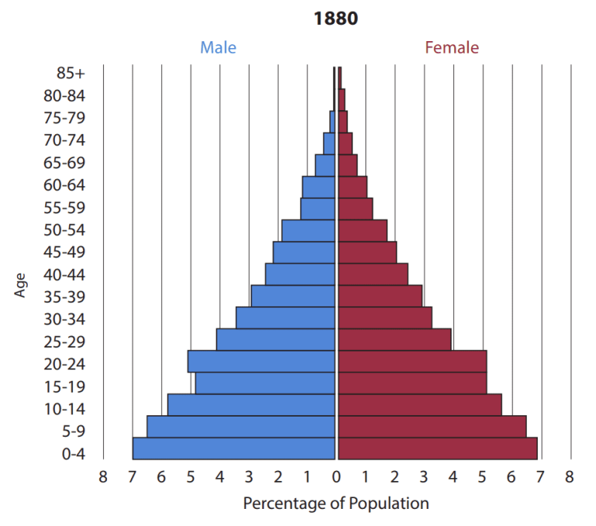
Figure 1: The caption/title should always be placed below the figure.
Source: Author’s work (2025).
TABLES
Ensure the tables are well-labelled and their relevant sources (for external tables) are included. This is to ensure any cited work is duly credited and to avoid possible instances of copyright violation. Tables should be titled as the example shows below:
Table 1: The caption should always be placed above the table
S/No | Question | Average | Means
1 | Asia | 110 | 1.1
2 | Africa | 222 | 2.2
3 | Europe | 339 | 3.3

REFERENCES

(Please review your in-text citations & references, and update accordingly using the APA Referencing style (7th or 8th edition). Ensure there are no omitted citations and correct all formatting errors in the references. Additionally, organise the references in alphabetical order)
Adamu, A., Reyer, F., Lawal, N., Hassan, A.J., Imam, M.U., Bello, M.B. and Kraiczy, P., 2024. Aetiologies of bacterial tick-borne febrile illnesses in humans in Africa: diagnostic limitations and the need for improvement. Frontiers in Medicine, 11, p.1419575. https://doi.org/10.3389/fmed.2024.1419575
Barnard, R., de Luca, R., & Li, J. (2016). First-year undergraduate students’ perceptions of lecturer and peer feedback: A New Zealand action research project. Studies In Higher Education, 40(5), 933–944. https://doi.org/10.1080/03075079.2016
Danladi, N., Philemon, M., & Williams, R. (2025). The Link Between Disclosure Of Sustainability Information and Corporate Financial Performance. Journal of Management Science and Entrepreneurship. 7(1), DOI: https://doi.org/10.70382/bejmse.v7i7.008
Easton, B. (2012). Does poverty affect health? In K. Dew & A. Matheson (Eds.), Understanding health inequalities in Aotearoa New Zealand (pp. 97–106). Dunedin, New Zealand: Otago University Press.
Ernest, N. E., & Nuhu, A. (2023). The effect of IFRS adoption on the value and applicability of accounting information for Dmbin Nigeria. International Journal of Foreign Trade and International Business, 5(1), 14-20. https://doi.org/10.33545/26633140.2023.v5.i1a.82
Grady, J. S., Her, M., Moreno, G., Perez, C., & Yelinek, J. (2019). Emotions in storybooks: A comparison of storybooks that represent ethnic and racial groups in the United States. Psychology of Popular Media Culture, 8(3), 207–217. https://doi.org/10.1037/ppm0000185
Pope, J. P., & Wall, H. (2025). Is the goal intrinsic or extrinsic? Examining self-determination theory researchers’ and the general publics’ perceptions of exercise goals. Canadian Journal of Behavioural Science/Revue canadienne des sciences du comportement, 57(3), 239–248. https://doi.org/10.1037/cbs0000411
Rush, E. C., Obolonkin, V., Battin, M., Wouldes, T., & Rowan, J. (2015). Body composition in offspring of New Zealand women: Ethnic and gender differences at age 1–3 years in 2005–2009. Annals Of Human Biology, 42(5), 492–497.
Rush, E., McLennan, S., Obolonkin, V., Cooper, R., & Hamlin, M. (2015). Beyond the randomised controlled trial and BMI--evaluation of effectiveness of through-school nutrition and physical activity programmes. Public Health Nutrition, 18(9), 1578–1581. https://doi.org/10.1017/S1368980014003322
Rybaczewska, M., & Sparks, L. (2022). Ageing consumers and e-commerce activities. Ageing and Society, 42(8), 1879–1898. https://doi.org/10.1017/S0144686X20001932

